

**AP Calculus BC**

Q1 Interim Assessment

Test Booklet 3

Scoring Guidelines

October 2017

School: _____________________________________________

Student Name: _____________________________________________

Teacher: _____________________________________________

Period: _____________________________________________

1. A 12,000-liter tank of water is filled to capacity. At time $t=0$, water begins to drain out of the tank at a rate modeled by $r(t)$, measured in liters per hour, where $r$ is given by the piecewise-defined function.

$$r\left(t\right)=\left\{\begin{aligned}\frac{600t}{t+3}, for 0≤t≤5 \\ 1000e^{-0.2t}, for t>5\end{aligned}\right\}$$

1. If $r$ continuous at $t=5$? Show the work that leads to your answer.
2. Find the average rate at which the water is draining from the tank between time $t=0$ and time $t=8$ hours.
3. Find $r'(3)$. Using correct units, explain the meaning of that value in the context of this problem.
4. Write, but do not solve, an equation involving an integral to find the time $A$ when the amount of water in the tank is 9000 liters.

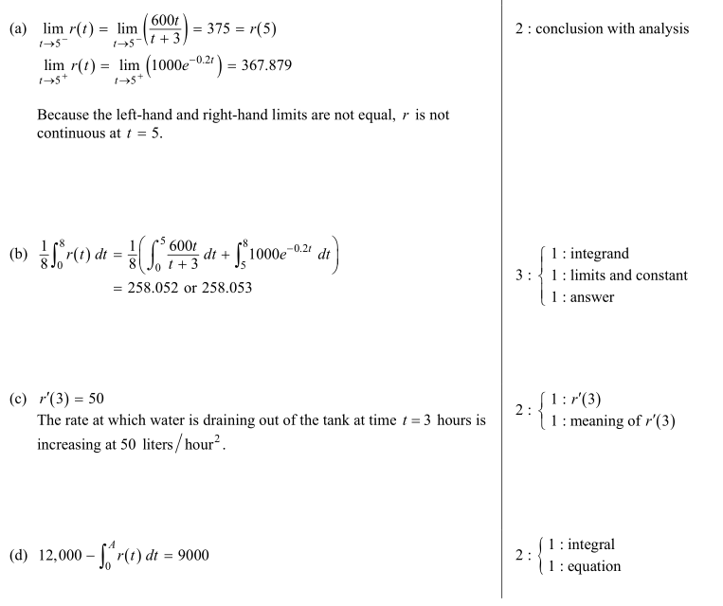

2. A particle moves along the $x$-axis with velocity at time $t≥0$ given by $v\left(t\right)=-1+e^{1-t}$.

1. Find the average acceleration of the particle on the interval $(0, 2)$.
2. Find the instantaneous acceleration of the particle at time $t=3$.
3. Is the speed of the particle increasing at time $t=3$? Give a reason for your answer.
4. Find all values of $t$ at which the particle changes direction. Justify your answer.

|  |  |
| --- | --- |
| $m/s^{2}$ | $$2:\left\{\begin{matrix}1:\frac{v\left(4\right)-v\left(2\right)}{4-2} \\ 1:answer with units\end{matrix}\right.$$ |
| is the instantaneous acceleration (rate of change) in  at . | $$3:\left\{\begin{matrix}1:v'(3) \\ 1:intepretation \\ 1:units\end{matrix}\right.$$ |
| Speed is increasing at  since  and . |  |
| 1. when , so .   for  and  for .  Therefore, the particle changes direction at . |  |

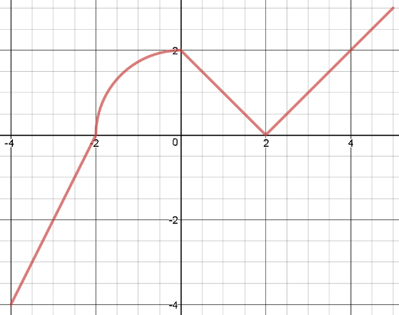

Graph of

3. Let be the continuous function defined on $\left[-4, 5\right]$, whose graph, consisting of a quarter circle centered at $(0, 0)$ and three line segments, is given above. Let $g$ be the function given by $g\left(x\right)=\int_{-2}^{x}{f(t)}dt$.

1. Find $g\left(2\right), g^{'}\left(2\right),$ and $g''(2)$, or state that the value does not exist.
2. For $-4<x<5$, find all values of $x$ for which the graph of $g(x)$ has a point of inflection. Explain your reasoning.
3. Find the interval(s) on which $g(x)$ is both increasing and concave down. Justify your answer.
4. Find the absolute maximum value of $g(x)$ on the closed interval $[-4, 5]$. Show the work that leads to your answer.

|  |  |
| --- | --- |
|  | 3 |
| 1. has a point of inflection at $x=\left\{0,2\right\}$ because ${g^{'}}^{'}\left(x\right)=f'(x)$ changes sign at those $x$-values. |  |
| 1. is increasing and concave down on $\left(0,2\right)$ because $g^{'}\left(x\right)=f(x)$ is positive and decreasing on this interval. |  |
| 1. The absolute maximum value of $g(x)$ is  |  |  | | --- | --- | |  |  | | -4 | 4 | | -2 | 0 | | 2 |  | | 5 | $$π+6.5$$ | | 2 |

|  |  |  |  |  |  |  |
| --- | --- | --- | --- | --- | --- | --- |
| (minutes) | 0 | 2 | 5 | 7 | 11 | 12 |
| $$r^{'}(t)$$ (feet per minute) | 5.7 | 4.0 | 2.0 | 1.2 | 0.6 | 0.5 |

4. The volume of a spherical hot air balloon expands as the air inside the balloon is heated. The radius of the balloon, in feet, is modeled by a twice-differentiable function $r$ of time $t$, where $t$ is measured in minutes. For $0<t<12$, the graph of $r$ is concave down. The table above gives selected values of the rate of change, $r^{'}(t)$, of the radius of the balloon over the time interval $0≤t≤12$. The radius of the balloon is 30 feet when $t=5$.

1. Approximate the value of $r''(6)$. Indicate units of measure.
2. Find the rate of change of the volume of the balloon with respect to time when $t=5$. Indicate units of measure.
3. Use a right Riemann sum with the five subintervals indicated by the data in the table to approximate $\int_{0}^{12}{r^{'}\left(t\right)dt}$.
4. Is your approximation in part (c) greater than or less than $\int_{0}^{12}{r^{'}\left(t\right)dt}$? Give a reason for your answer.

|  |  |
| --- | --- |
| $r^{''}\left(6\right)≈-0.4$ $\frac{feet}{minute^{2}}$ | $$2:\left\{\begin{aligned}1:approximation \\ 1:units\end{aligned}\right\}$$ |

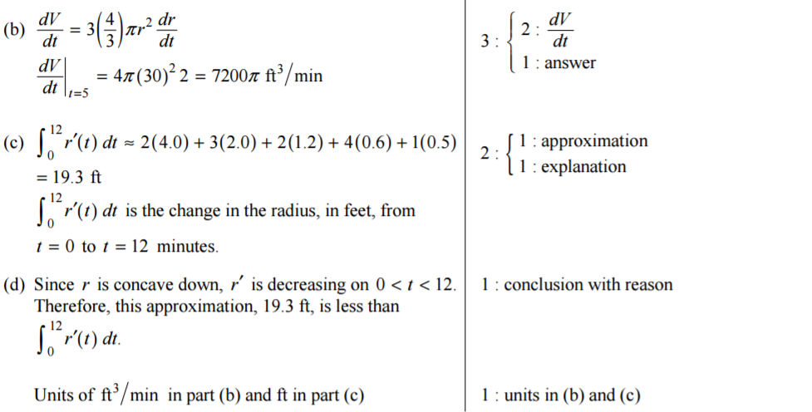

**^^^^ AWARDED IN QUESTION (C)** _____

5. Consider the curve known as the Folium of Descartes, given by the equation $x^{3}+y^{3}=3xy$.

1. Show that $\frac{dy}{dx}=\frac{y-x^{2}}{y^{2}-x}$.
2. Find the coordinate(s) of all points on the curve for which the tangent line is vertical.
3. Find the equation of the line tangent to the curve at the point $\left(\frac{3}{2},\frac{3}{2}\right)$.
4. Let $x$ and $y$ be functions of time $t$ that are related by the equation $x^{3}+y^{3}=3xy$. At time $t=2$, the values of $x=y=\frac{3}{2}$ and $\frac{dx}{dt}=10$. Find the value of $\frac{dy}{dt}$ at time .

|  |  |
| --- | --- |
|  |  |
|  |  |
|  |  |
|  |  |

6. Let be a differentiable function for which $f\left(0\right)=8$ and whose derivative is given by the equation $f'\left(x\right)=-2e^{x}(x-8)$ for all $x≥0$.

1. Find the *x*–coordinate of the critical point of *f*. Determine whether this point is a relative minimum, a relative maximum, or neither for the function *f*.
2. The graph of the function *f* has exactly one point of inflection. Find the *x*–coordinate of this point.
3. Find the equation of the tangent line to the curve $y=f(x)$ at the point where $x=0$. Use the tangent line to approximate the value of $f(-1)$.
4. Evaluate .

|  |  |
| --- | --- |
| 1. at   changes from positive to negative at .  Thus, *f* has a relative maximum at . | $$2:\left\{\begin{matrix}1:x-value \\ 1:justification\end{matrix}\right.$$ |
| at  changes from positive to negative at . Thus, the graph of *f* has a point of inflection when . |  |
|  |  |
| 1. by L’Hopital’s Rule $$f^{'}\left(0\right)= -2e^{0}\left(0-8\right)=16$$  Answer: $\frac{16}{6}=\frac{8}{3}$ | $$2:\left\{\begin{matrix}1:L^{'}Hopital^{'}sRule \\ 1: Answer\end{matrix}\right.$$ |